
TRIBHUVAN UNIVERSITY
INSTITUTE OF ENGINEERING
PULCHOWK CAMPUS

Final Year Project Proposal
On
CORVID – Intelligent Email Processor

Submitted By

Lekhnath Bhusal (060BCT515)
Madhav Sigdel (060BCT516)
Mahesh Raj Regmee (060BCT517)
Prajwal Shrestha (060BCT528)

SUBMITTED TO THE
DEPARTMENT OF ELECTRONICS AND COMPUTER ENGINEERING IN PARTIAL FULFILLMENT OF THE REQUIREMENT FOR BACHELOR’S DEGREE IN COMPUTER ENGINEERING

August 2007
August 16, 2007

To,
Asst. Prof. R. L. Rajbhandari
Project Coordinator
Department of Electronics and Computer Engineering

Subject: Submission of Major Project Proposal

Dear Sir,
This is to inform you that we, group of four students, have selected “CORVID - Intelligent Email Processor” as our major project in partial fulfillment of requirement for Bachelor’s Degree in Computer Engineering.
Email has been the cheapest and easiest way of communication. Email clients have simplified its use by archiving mails and mail filtering. However, these do not address the changing requirements of users. Many researches are going on for adopting intelligence in filtering, classification and summarization of emails. Emails are highly unstructured data. So, a single algorithm can not address all the issues. We aim to develop a system flexible enough to learn changing user interests. Besides this we will use effective algorithms and employ a combination of them. This is entirely a research based project in the field of Artificial intelligence.
We will work as per the schedule outlined in this proposal and finish the project within the given deadline. We will devote our time and effort to achieve the goals mentioned in this proposal. We are looking forward to kindly approval of our project.

Yours sincerely,
Lekhnath Bhusal (060BCT515)
Madhav Sigdel (060BCT516)
Mahesh Raj Regmee (060BCT517)
Prajwal Shrestha (060BCT528)

Acknowledgement

Secret behind every successful project is proper planning, sufficient preliminary studies and smart goal setting. Continuous help from various persons was vital in refining the goals to come up with solid project objectives. In this regard, the authors would like to express their vote of thanks to following people/organizational unit.

- Department of Electronics and Computer Engineering, Pulchowk Campus for its initiatives in carrying out this project.
- D2Hawkeye Services, Bishalnagar for its guidelines and support for the project
- R. L. Rajbhandari (Assist. Professor), B. E. Project Coordinator, DOECE Pulchowk Campus for his coordination and relevant information for project.
- Prof. S.R Joshi for his valuable suggestion during the project selection.
- Shankar Raj Uprety, Senior Engineering manager, D2Hawkeye Services and Subash Devkota, Software Engineer D2Hawkeye Services, Bishalnagar for their helpful suggestion and supervision in setting goals and proposal development.
- Our seniors for their valuable materials and suggestions.
- Our friends and family for their direct or indirect support in project study.

Abstract

Email satisfies the basic human need for communication and has become mission critical in every organization. Billions of emails are delivered each day connecting people around the globe. Unfortunately, majority of these emails are unsolicited bulk emails or spam. Automatic filtering of such mails has become a must. Even there are large numbers of necessary emails related to diverse fields in a user’s inbox. So, email management in a well classified form is necessary. Also it is difficult to extract important information from sequence of mail replies or a long mail. A good summarization tool can spear user from this tedious task. Mozilla Thunderbird is one of the mostly used email client which provides offline email management and filtering. However, the approach used for filtering and classification of emails are static and does not meet the changing requirements of users. If learning can be incorporated into the system by tracking user’s actions to emails, we can automate such tasks and help the user in managing his inbox.
CORVID is a solution to these problems. It is a module that adds intelligence to email client for filtering and classification of emails as well as for summarizing email threads. CORVID learns from user activities on the received emails and goes on increasing its knowledgebase. Initially, its knowledgebase is empty. CORVID keeps track of user activities on the emails and updates its knowledgebase. It also provides the facility of extraction of important information from long sequence of email replies. The project is developed for the partial fulfillment of requirement for Bachelor’s in Computer Engineering and is done in co-operation with D2Hawkeye Services, Bishalnagar.
Table of Contents

Acknowledgement ii
Abstract iii
1 Introduction 1
1.1 Background 1
1.2 Problem Statement 1
1.3 Objectives 2
2 Literature Review 2
3 Feasibility Analysis 4
3.1 Operational Feasibility 4
3.2 Technical Feasibility 4
3.3 Economic Feasibility 4
3.4 Schedule Feasibility 4
3.5 Risk Analysis 5
4 Proposed System 5
4.1 Overview 5
4.2 System Description 5
4.3 System Design 7
4.4 System Requirements 10
5 Project Scheduling 10
6 Expected Results 11
7 Concluding Words 11
References 12

List of Figures

Figure 1 General Architecture of Proposed System 7
Figure 2 Internal Architecture of CORVID 8
Figure 3 Basic Flowchart showing Processes, Inputs and Outputs in the system 9

1 Introduction

Background
Email (Electronic Mail) is one of the most important applications used to communicate over the Internet. It is a store and forward method of composing, sending, storing, and receiving messages over electronic communication systems. It is a push-only medium: The control of who is receiving which information is mainly with the sender. Hence this leads to an overflow of unwanted information. Even the necessary emails are in large number and it is difficult to identify important information from a sequence of emails. Email service is provided in different mechanisms such as web-based or mail client. Web based mail service can be accessed from anywhere through the internet however they only provide generic services and require internet accessibility. Web based mail servers provide generic services. User specific services are not directly available in the servers. For such services and offline email achieving email client is required.
There have been different research in the field of Email filtering and different algorithms have been devised. Bayesian classification has been the mostly used one. Different mail service providers provide anti-spam techniques. Web mail providers such as Gmail, Yahoo have applied static mail filtering algorithms and appropriate actions such as deleting the mail, moving a folder etc. can be defined. Mail clients like Mozilla Thunderbird and Microsoft Outlook Express have made filtering techniques very robust. Mailwasher Pro has also incorporated Bayesian learning for spam mail detection. POPFile is another similar application which sorts mail in different categories such as (family, friends, co-worker, spam etc.) with Bayesian filtering.

Problem Statement
Most of the existing applications found so far use static filters and hence do not address the changing requirements. Likewise, some use Naïve Bayesian for classification which considers single words as features and spammers have already devised techniques to override such filters. Email Classification is limited to detection of Spam or Ham emails. Also summarization feature is not present which can help in prioritizing email and generating alerting actions for important messages.

Objectives
We propose to develop a system that can learn user preferences for filtering and categorization of email from user activities pertaining to an email message. Along with this, it is required to generate relevant summary of email threads. To achieve this, we have set the following objectives:
- Develop a module for email filtering
- Develop email classification module
- Develop email summarization module
- Integrate the above modules as an extension to Mozilla Thunderbird

Literature Review

Machine learning
Machine learning is concerned with the design and development of algorithms and techniques that allow computers to "learn". At a general level, there are two types of learning: inductive, and deductive. Inductive machine learning methods extract rules and patterns out of massive data sets. The major focus of machine learning research is to extract information from data automatically, by computational and statistical methods. Hence, machine learning is closely related to data mining and statistics but also theoretical computer science.

Mail Server
A mail transfer agent or MTA (also called a mail transport agent, message transfer agent, mail server, or a mail exchanger in the context of the Domain Name System) is a computer program or software agent that transfers electronic mail messages from one computer to another. It receives messages from another MTA (relaying), a mail submission agent (MSA) that itself got the mail from a mail user agent (MUA), or directly from an MUA, thus acting as an MSA itself. The delivery of e-mail to a user's mailbox takes place via mail delivery agent (MDA).

Email Client
An e-mail client is a front end computer program used to manage e-mail. Mozilla Thunderbird, Outlook Express, Evolution Mail are some of the popular email clients. Email Clients use POP3 or IMAP to retrieve messages and use SMTP to send messages.. Fewer Internet Service Providers (ISPs) support IMAP.

E-mail spam
E-mail spam, also known as bulk or junk e-mail is a subset of spam that involves sending nearly identical messages to numerous recipients by e-mail. A common synonym for spam is unsolicited bulk e-mail (UBE). Some definitions of spam specifically include the aspects of email that is unsolicited and sent in bulk.

POP3
Post Office Protocol version 3 (POP3) is an application-layer Internet standard protocol to retrieve e-mail from a remote server over a TCP/IP connection. POP3 has made earlier versions of the protocol (POP1 and POP2) obsolete. The design of POP3 and its procedures supports end-users with intermittent connections (such as dial-up connections) to retrieve e-mail when connected and view and manipulate staying offline.
POP3 works over a TCP/IP connection using TCP on network port 110. E-mail clients can encrypt POP3 traffic using TLS or SSL.

IMAP
The Internet Message Access is an application layer Internet protocol operating on port 143 that allows a local client to access e-mail on a remote server. IMAP supports both connected and disconnected modes of operation. E-mail clients using IMAP generally leave messages on the server until the user explicitly deletes them. IMAP is often used in large networks; for example, a college campus mail system. It allows users to access new messages instantly on their computers, since the mail is stored on the network.

Feasibility Analysis

Operational Feasibility
Mozilla Thunderbird is a popular mail client and CORVID is an extension to it with added intelligence in filtering, email classification and support for email summarization. Since, this functionality can be easily incorporated in the existing system the project will definitely be useful to the users. Users will benefit from the intelligence added to Thunderbird. The confidence of CORVID system will go on increasing as it is used and can suggest things intelligently. The confidence level will be less in the early usage of the system.

Technical Feasibility
CORVID is an extension to Thunderbird; therefore we require good knowledge of the design and implementation of it. Thunderbird is open source and its documentation is readily available. Also we can get support from the forums of Thunderbird. Besides we are building the project in co-operation with D2hawkeye Services, Bishalnagar from where we obtain good support and supervision from our mentors. The help of supervisors, access to information in the internet and different books, research papers and articles will suffice.

Economic Feasibility
The development of CORVID requires Mozilla Thunderbird source code which is open source and GPL licensed. The tools required for the development and extension of Thunderbird is also easily available, therefore there is no cost for the tools. Further the project is an academic project. Therefore costs of manpower are not involved. This makes the project economically feasible.

Schedule Feasibility
The time period of 4 months is a short time for this project which requires extensive research and experiments. But the target is to provide basic functionalities and develop it as an extension to Mozilla Thunderbird. Thus basic requirements can be fulfilled within the time frame.

Risk Analysis
CORVID is a project incorporating Artificial Intelligence and hence requires extensive research. We are a group of four members and have time limit of around 4 months which is very less for this sort of project. However, different algorithms have been devised for email filtering and email classification. Due to time constraint, we will study and implement these algorithms instead of developing new algorithms and build a basic framework for developing such system. Hence implementation of these algorithms may possess some risk in performance level. But the application can be developed within the time frame.

Proposed System

Overview
CORVID is an intelligence extension to email clients and specifically to Mozilla Thunderbird. It adds the functionality of Email filtering and classification through learning of users actions to emails and also provides the facility of extraction of important information from long sequence of email replies. It applies statistical classification techniques. It uses context information to best address the association of features within the email. It uses learning algorithms to learn domain specific knowledge from the email examples and suggests the best class for user’s email. It uses machine linguistic and learning technique for summarization.

System Description
CORVID is consists of following components. These are briefly discussed below.
- Email Client Interface
- Critic Module
- Knowledgebase
- Preprocessing Module
- Learning Module
- Filtering Module
- Classification Module
- Summarization Module
Email client interface module is direct extension to email client, Mozilla Thunderbird. It bridges between the email client and our system. Client communicates with mail servers and stores emails in the inbox. Interface module extracts this email, stores it into classified folders and provides support for critic module to track user activities.
Critic module listens to user activities pertaining to incoming mails and user reaction towards CORVID’s email classification. The feedback so generated is reflected as knowledgebase update.
Knowledgebase is in the form of file system. It stores the knowledge base for email classification and filtering. Each record in the knowledgebase represents statistical information of the features in email header and message body of the sample emails and subsequent classified emails.
Email preprocessing module applies text processing to extract the features in the header and message body. The preprocessing requires following steps
- Lexical analysis and keyword extraction
- Removing stop words (common words like preposition, article, etc.)
- Phrase construction
Learning module updates knowledgebase using the information provided from critic module and reflects user’s changing behavior in the knowledgebase.
Filtering module uses features from the knowledgebase and applies email filtering algorithms to filter the incoming mails. It stores spam mails in an archive for user feedback. The filtered emails are forwarded for classification.
Classification module uses class specific features from preprocessing of email and the corresponding knowledgebase and classifies emails using email classification algorithm.
Summarization module finds the complete thread of emails from user’s inbox using email quotation. Then, it generates summary using the semantics and features of the thread.
The classes represent the categories into which emails can be classified. These are created as folders into which appropriate mails are achieved. Initially, the knowledgebase is empty. Client extension module extracts mails from the client inbox. Emails classified by the user are used as training emails for learning module. Learning module extracts the features and updates the knowledgebase. Filtering and Classifier module use this knowledge. The critic tracks user activities for incoming emails and updates knowledgebase continuously. In this way, using the knowledgebase filtering and classification of emails can be done with higher confidence level. When knowledgebase becomes confident enough, classifier classifies the incoming emails. Filter module filters and archives the filtered emails. If user is not satisfied with the filter and classification, he/she can override this. Critic module tracks this action and updates the knowledgebase. In this way, system continuously becomes personalized for a specific user.

System Design

Figure 1 shows the general architecture of the proposed system. The CORVID extension will be added to the Mozilla Thunderbird and knowledge base will be updated over user’s action over the mail. The Mozilla Thunderbird, CORVID extension and the knowledge base will be the system in the client that interacts with the mail server using POP3 or IMAP protocols for receiving mails and SMTP for sending mails.
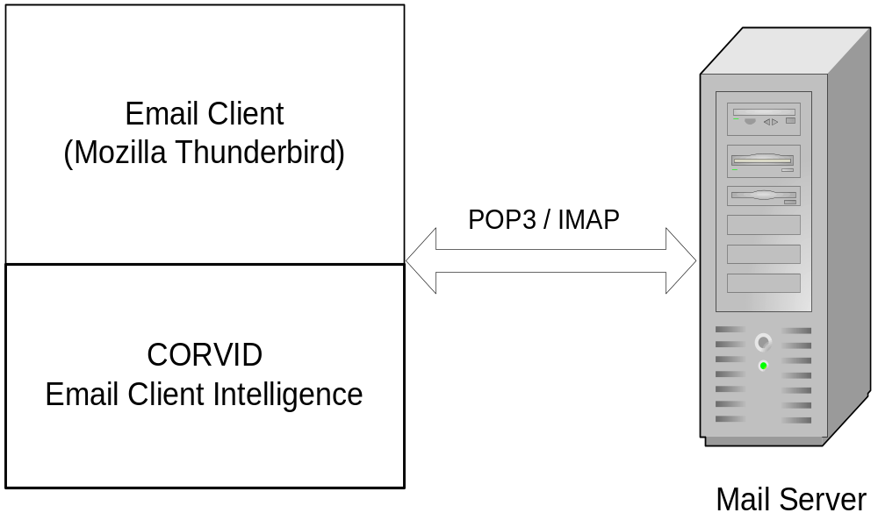
Figure 1 General Architecture of Proposed System
Figure 2 depicts the internal architecture of the proposed system. The CORVID system will be added into Mozilla Thunderbird. The basic components in the extending system are Filter Engine, Classification Engine, Summarization Engine and Learning Engine. The learning for email filtering and email classification is a continuous process. The knowledge base for summarization is however static. For the classification of a mail, it is first passed through Filter Engine. It goes to the Classification Engine only if it is identified as a ham mail.
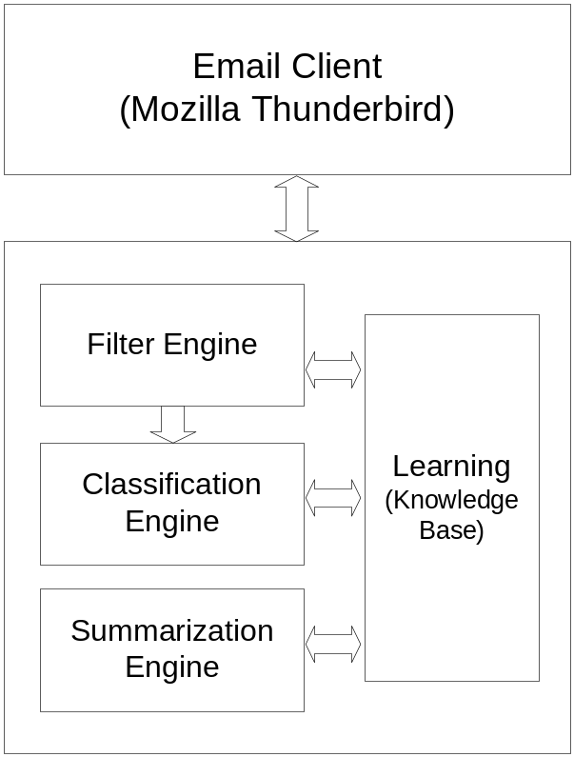
Figure 2 Internal Architecture of CORVID

The basic processes and the flow of inputs and outputs in the system are shown in the flowchart in Figure 3. The user’s management mails in his inbox or other folders are tracked upon and this updates the knowledge base. To each new mail in the user’s inbox, it is first tested whether it is ham or spam. If the mail is identified as spam with confidence factor above threshold, it is moved to spam folder. If the mail is identified as ham mail with confidence factor above threshold, it is further processed for classification. Otherwise the user’s action over the mail is tracked and knowledgebase is updated accordingly. Similar process goes for the classification of the ham mail. The classification algorithms and the knowledgebase for classification are used. The summarization can be done for the ham mails. Firstly all the sequence of email replies is collected and important information are extracted and a summary is generated.
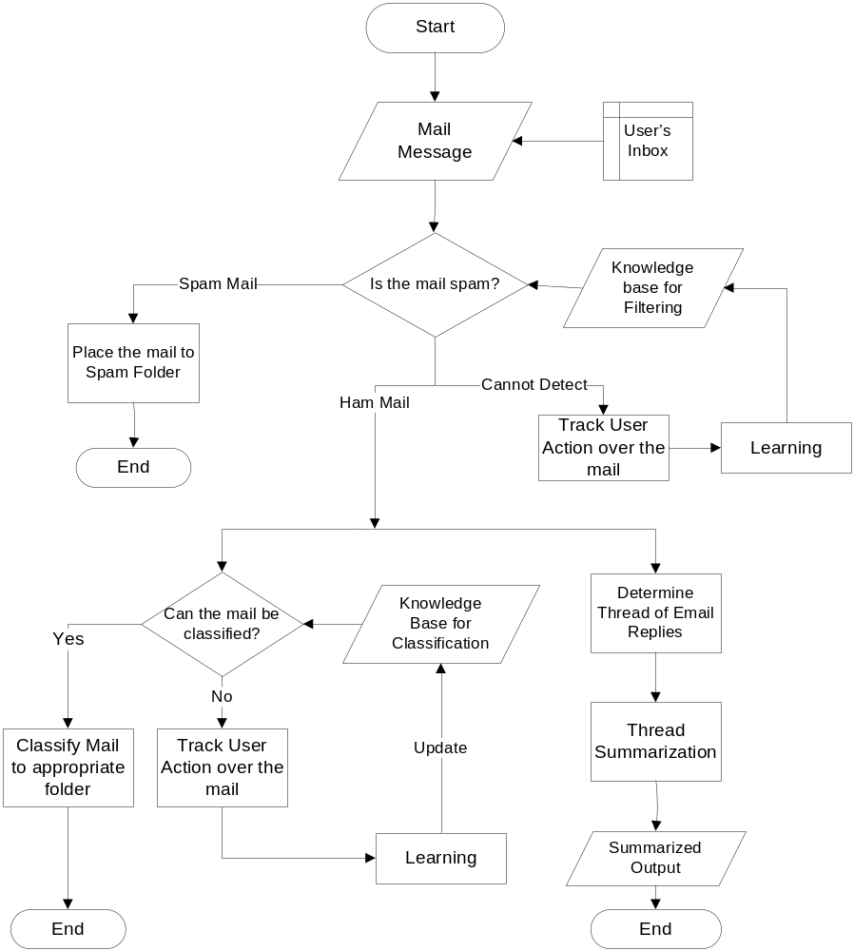

Figure 3 Basic Flowchart showing Processes, Inputs and Outputs in the system

System Requirements

Operating System
Linux
Windows

Platform:
- JavaScript
Primary scripting language in mozilla and the language in which extensions are written.

- XPCOM (Cross Platform Component Object Model)
Collection of core Mozilla modules and platform to develop user modules.

- XUL (XML User Interface Language)
Used to define the onscreen layout of the UI and to attach scripts and style to the interface.

Project Scheduling

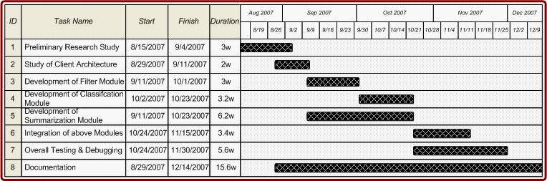

Expected Results

The product developed is an extension for the current Thunderbird client. It will be used in conjunction with the main product. This will ease the user in managing his/her mails by personalization and learning behavior of the client. Since, the system gains confidence through the user’s action, and learning is a continuous process, the system might not produce best results during early use of the application.

Concluding Words
We’ll implement sound and complete algorithms to achieve the effective classification and filtering of the emails. We shall use those algorithms that do not consider word frequency as the only features. These will be more relevant as they take into consideration the context or association of phrases. Summarization will be based on linguistic analysis so that important information can be extracted from large mails or sequence of mail replies. We expect that our project will be an effective application for email-client users to efficiently manage their inbox. We anticipate full co-operation and seek necessary resources and guidelines which will help us to complete the project within time and make the project the best and effective one.

References

- Ruth Bergman, Martin Griss, Carl Staelin, A Personal Email Assistant, HP Laboratories Palo Alto, HPL-2002-236, August 22nd , 2002
- John Graham-Cumming, Three years of Spam Mutation. In the Proceedings of The Spammer’s Compendium, January 2003
- Marti Hearst, Applied Natural Language Processing, In the Proceedings of Presentation on Natural Language Processing for Email, October 2004
- Jason D. M. Rennie, ifile: An Application of Machine Learning to Email Filtering. At the Artificial Intelligence Lab Massachusetts Institute of Technology, Cambridge.
- Xavier Carreas and Llujes Marquez, Boosting Trees for Anti-Spam Filtering, TALP Research Center, September 2001.
- Victor R. Carvalho & William W. Cohen, Learning to Extract Signature and Reply Lines from Email, in CEAS 2004
- Mehran Sahami, Susan Dumais, David Heckerman and Eric Horvitz, A Bayesian Approach to Filtering Junk Mail. In the Computer Science Department Stanford University.
- Gary Boone, Concept Features in Re-Agent, an Intelligent Email Agent, Georgia Institute of Technology.
- Richard Cole, Gerd Stumme, CEM- A Conceptual Email Manager. School of Information Technology, Griffith University Gold Coast Campus
- Giuseppe Manco, Elio Masciari, Massimo Ruffolo, Andrea Tagarelli, Towards An Adaptive Mail Classifier
- Julia Itskevitch, Belorussian, Automatic Email Classification using Association Rules. State Polytechnic Academy, 1997
- Shaun Abushar and Naoki Hirata, Filtering with Intelligent Software Agents
- Smaranda Muresan, Evelyne Tzoukermann, Judith L. Klavans, Combining Linguistic and Machine Learning Techniques for Email Summarization
- Xiaodong Zhou, Email Mining and Summarization
- http://citeseer.ist.psu.edu/
- http://www.media.mit.edu/
- http://www.wikipedia.org/
- http://www.mozilla.org/
- http://www.xulplanet.com/

Project Members

Lekhnath Bhusal
Roll No: 060BCT515
Email: lekhnathbhusal@gmail.com
Contact No: 9841679323

Madhav Sigdel
Roll No: 060BCT516
Email: madhav_sigdel@yahoo.com
Contact No: 9841542563

Mahesh Raj Regmee
Roll No: 060BCT517
Email: maheshregmee@gmail.com
Contact No: 9841611806

Prajwal Shrestha
Roll No: 060BCT528
Email: prajwalsh@gmail.com
Contact No: 9841303981

